Semester: VII Name of Student:Sonika Sawant
Academic Year:2026-2027 Student ID:23104054
Class / Branch: BE IT-B
Subject:Recent Open Source Lab
Name of Instructor: Prof. Jayshree Jha

EXPERIMENT NO. 04

Aim: To examine various open-source quality assurance tools like Selenium, Katalon, Cucumber and identify steps for maintaining quality using Selenium.

Selenium is a powerful, open-source tool used for automating web browsers. It allows developers and testers to simulate user actions like clicking, typing, and navigating through web pages. Selenium is widely used for testing web applications, automating repetitive browser tasks, and web scraping.

Key Features:
- Browser Automation: Automates actions in browsers like Chrome, Firefox, Safari, and more.
- Cross-Browser Testing: Supports different browsers, enabling testing across various platforms.
- Programming Languages: Can be used with multiple languages such as Python, Java, C#, Ruby, and JavaScript.
- WebDriver: Selenium’s main component, allowing interaction with web pages via real browsers.
- Element Interaction: Allows locating elements using various strategies (e.g., by ID, name, XPath) and interacting with them (clicking, typing, etc.).
- Open Source: Free to use with a large community for support.

Prerequisites:
- Install Python: Ensure Python is installed on their systems.
- Install Selenium: Run the following command in the terminal:
pip install selenium
- Download WebDriver: Download the appropriate WebDriver for the browser you’ll be using (e.g., ChromeDriver for Chrome). Ensure the WebDriver is in the system path.

Basic Demo :Automating a Google Search

Set up the environment using Python Code Example:
# Import Selenium WebDriver
from selenium import webdriver
from selenium.webdriver.common.keys import Keys

# Set up WebDriver (Chrome in this case)
driver = webdriver.Chrome()

# Open Google
driver.get("https://www.google.com")

# Print page title
print(f"Page title: {driver.title}")

# Find the search box element using its name attribute value
search_box = driver.find_element("name", "q") # Check area-label

# Type a query into the search box
search_box.send_keys("Selenium WebDriver demo")

# Simulate pressing Enter
search_box.send_keys(Keys.RETURN)

# Wait for the results page to load and display the results
driver.implicitly_wait(5)

# Print the title of the new page
print(f"New Page title: {driver.title}")

# Close the browser
driver.quit()

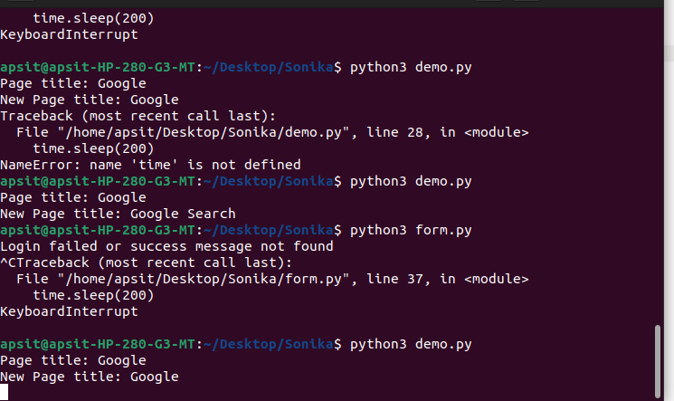
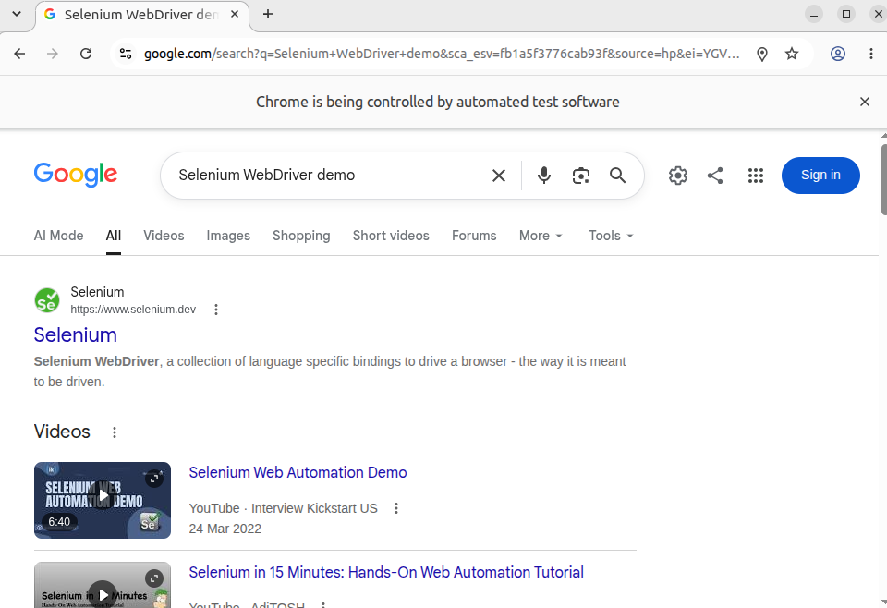

Demo 2: Automating a Form on a Website (Example: A login form)

#Importing Selenium WebDriver
from selenium import webdriver
from selenium.webdriver.common.keys import Keys
from selenium.webdriver.common.by import By
import time

# Step 1: Set up WebDriver for Chrome (or your preferred browser)
driver = webdriver.Chrome()

# Step 2: Open a demo login page (you can replace this URL with any real form page)
driver.get("https://www.saucedemo.com/")

# Step 3: Find the username and password input fields using their name or ID
username = driver.find_element(By.NAME, "user-name") # You may have to replace 'username' with the actual field name on the site
password = driver.find_element(By.NAME, "password") # Replace 'password' with the actual field name

# Step 4: Type values into the input fields
username.send_keys("standard_user") # A dummy username
password.send_keys("secret_sauce") # A dummy password

# Step 5: Locate the submit/login button and click it
#submit_button = driver.find_element(By.XPATH, "//button[@type='submit']") # Example using XPATH
submit_button = driver.find_element(By.NAME, "login-button")
submit_button.click()

# Step 6: Wait for the new page to load
time.sleep(3) # Wait for 3 seconds for the next page to load

# Step 7: Extract result (for example, if there’s an element with a success message)
try:
success_message = driver.find_element(By.ID, "success-message") # Replace with the actual element's ID
print(f"Login successful: {success_message.text}")
except:
print("Login failed or success message not found")

# Step 8: Close the browser after completion
driver.quit()

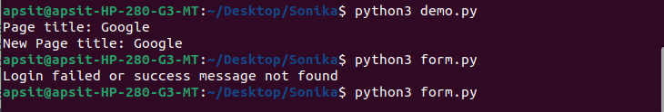
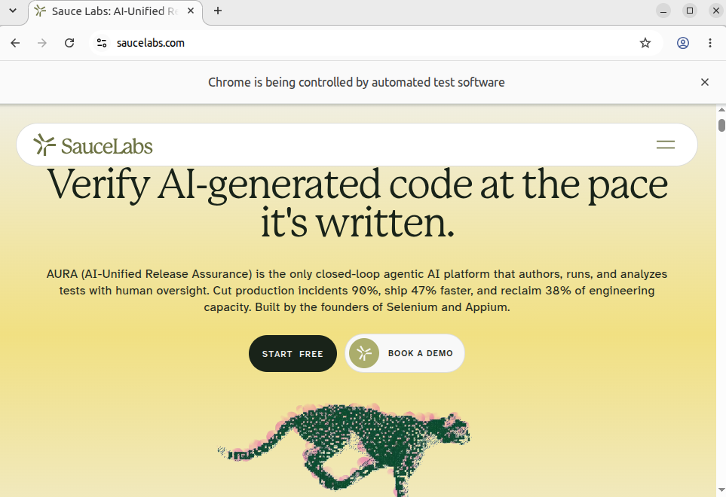

Steps to Contribute in Selenium WebDriver :

1.Download the code from:

https://github.com/SeleniumHQ/selenium

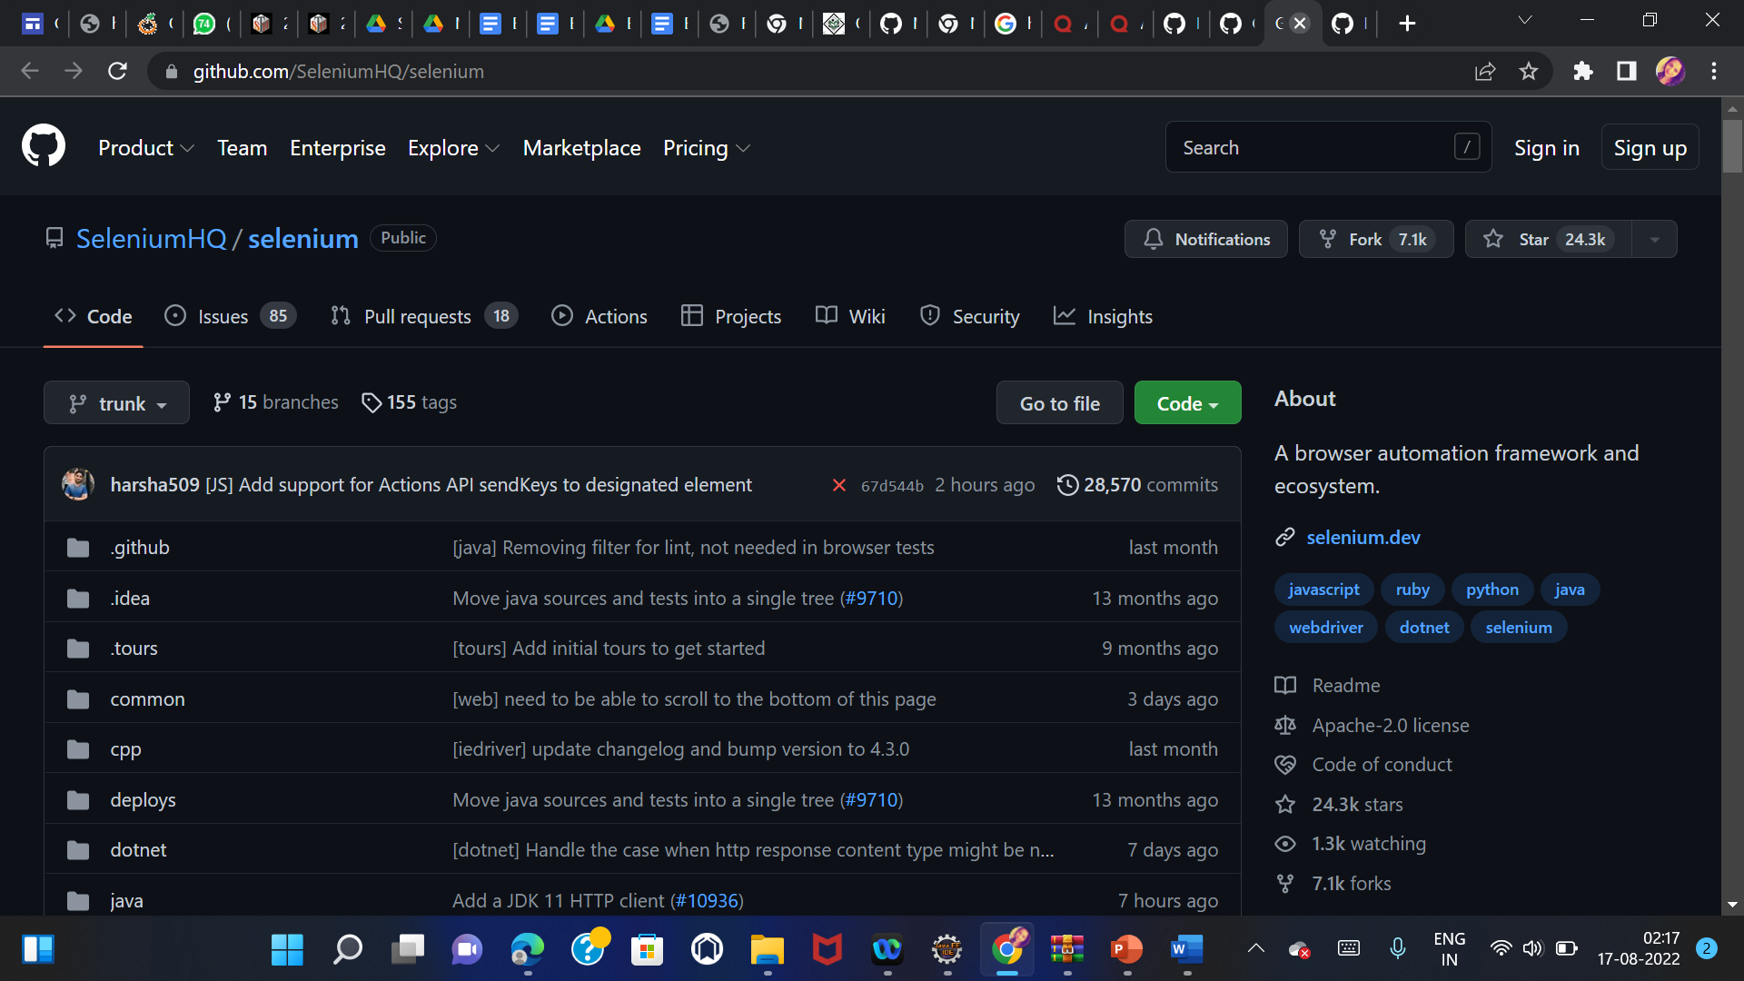

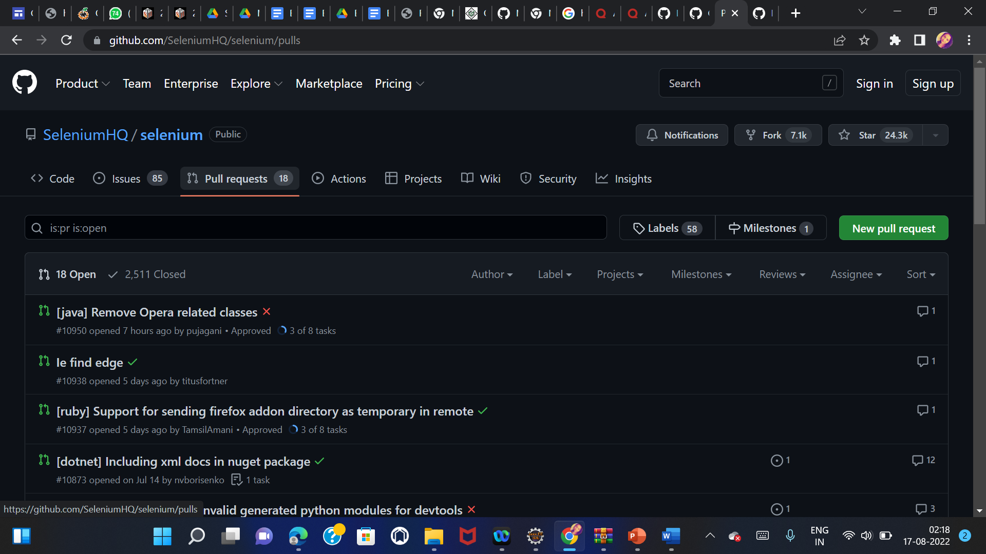

2. Find the open issue you can contribute in below link

https://github.com/SeleniumHQ/selenium/issues

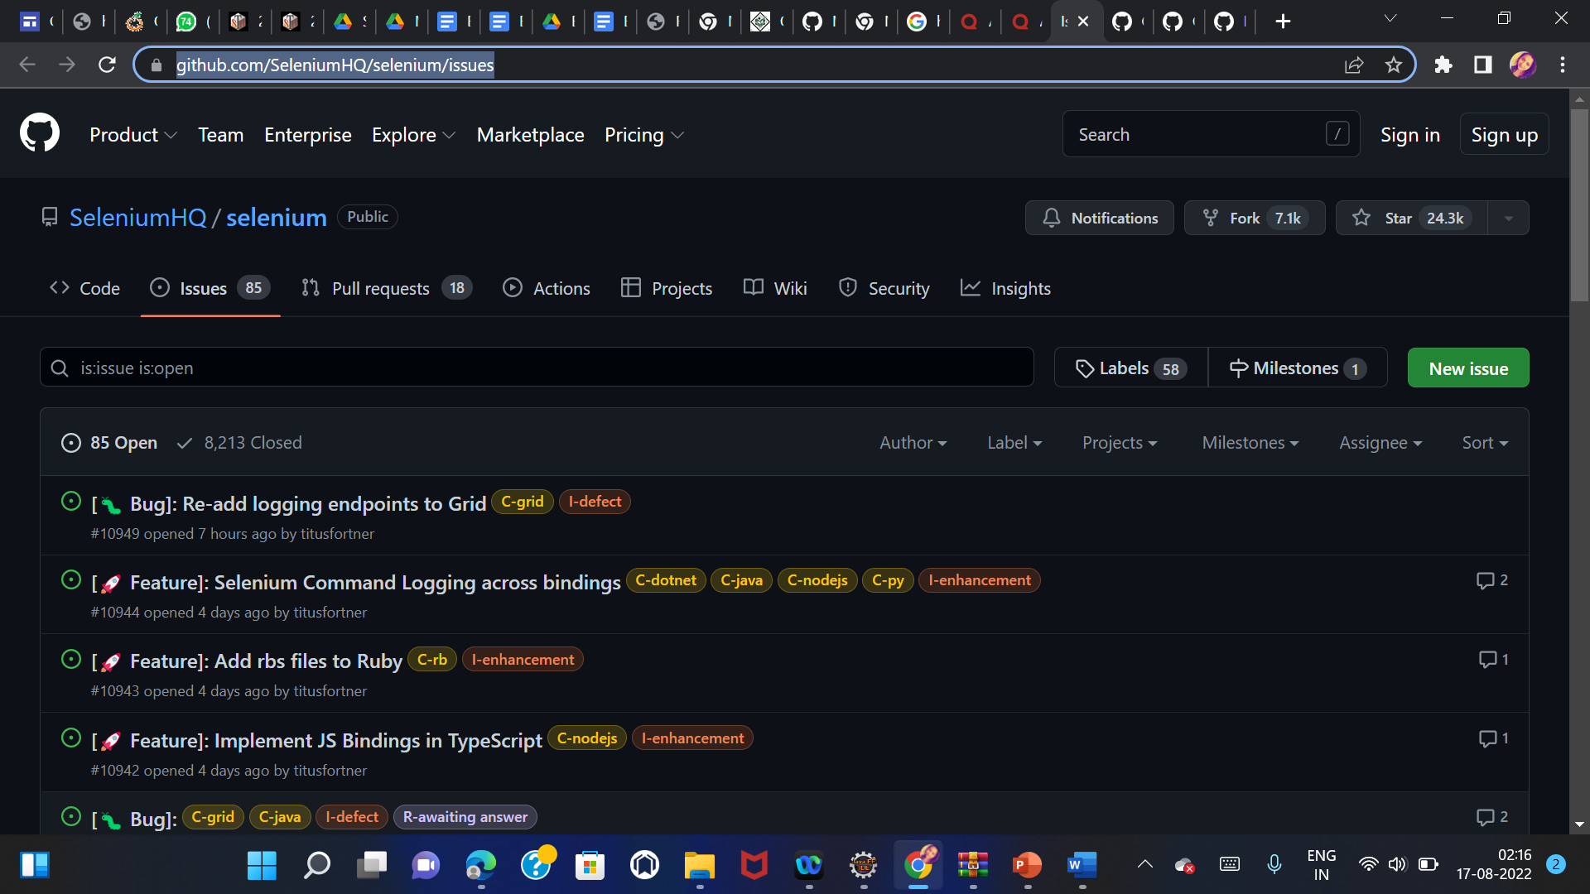
3. Commit the code and after review your code can be part of official Jar

Conclusion : Thus We have studied different Open source Testing tool and steps to contribute in Selenium WebDriver.

